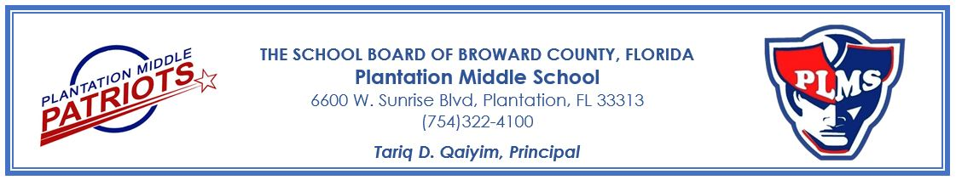

**Plantation Middle School**

**School Advisory Council (SAC)**

**2024-2025**

**Meeting Dates**

Wednesday, September 4, 2024

Wednesday, October 2, 2024

Wednesday, November 6, 2024

Wednesday, December 4, 2024

Wednesday, January 8, 2025

Wednesday, February 5, 2025

Wednesday, March 5, 2025

Wednesday, April 2, 2025

Wednesday, May 7, 2025

Each meeting will be held at 5:30pm in the Media Center.

If you have any questions, or would like to join the SAC Committee, please contact the SAC Chair, Latavia Pinckney at 754.322.4100.

**“Excellence is the Expectation!”**